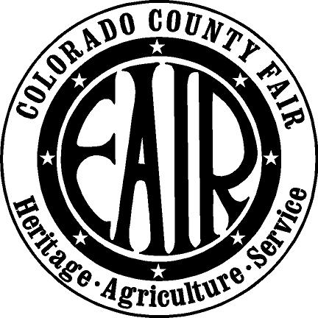
Colorado County Junior Fair Board
Scholarship Application

Applicant Name: ____________________________________________________________
First Middle Last
Address: ___________________________________________________________________
Phone Number: _______________________ Cell Number: _______________________
Date of Birth: ________________________ Graduation Date: ______________________
Senior Class Rank (#): ____________ Graduation GPA: ________________________
ACT Score: ____________________ SAT Score: _____________________________

List the Members of Your Immediate Family:

Name Relation Age Address Occupation

1) _______________________________________________________________________________
2) ________________________________________________________________________________
3) ________________________________________________________________________________
4) _________________________________________________________________________________
5) _________________________________________________________________________________
6) _________________________________________________________________________________

List the College(s) you’ve applied to & have you been accepted?
1.______________________ Yes or No
2.______________________ Yes or No
3.______________________ Yes or No

What is your planned field of study?

What did you learn while a member of JFB and why should you receive a JFB scholarship?

Do you plan on returning to volunteer at the Colorado County Fair? If so, what area are you interested in?

Please Attach a Resume

Please sign after reading the following statement. “To the best of my knowledge all the information I have provided is correct.”

Applicant Signature: _______________________________________ Date: ______________

Parent/Guardian Signature: ___________________________________ Date: _____________

